The 9th CASEE Conference
Researched based education at life science universities in the Danube region towards a sustainable future

University of Agronomic Sciences and Veterinary Medicine, Bucharest, Romania, 6 – 9 June, 2018

Section III. Sustainable food systems and quality

Prof. Dr. Teodor Trasca
BUASVMT, Romania

Prof. Dr.hab. Ewa Rembialkowska
WULS, Poland

2018, June 8 The 9th CASEE Conference, Bucharest, Romania
Professor Ewa Rembialkowska, Professor Teodor Trasca
1

25 Abstracts 11 Oral presentations
(9 presented)

11 Posters

3 1
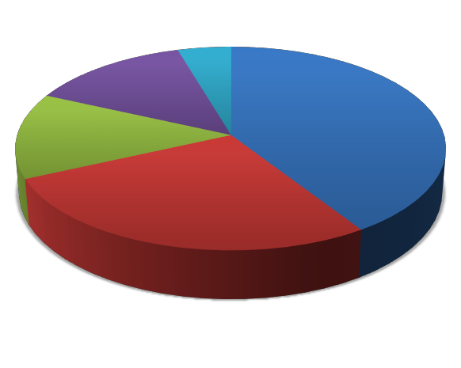9 USAMV Cluj
3 USAMV Bucuresti

WULS

6 USAMV Timisoara
BOKU

3a.01 Development of tailormade food waste prevention measures based on consumer type analysis, Schwödt Sandra, Obersteiner G., BOKU Vienna, Austria

-research financed by the Interreg Central Europe project STREFOWA – Strategies to reduce and manage food waste in Central Europe, 2016 – 2019
-more than 2000 people completed online questionnaire
- cluster analysis to divide the consumer into certain groups
- 10 tips about food waste prevention
- First Aid Box for Food – distributed in Food supermarkets in Vienna
- www.reducefoodwaste.eu
- similar studies in DE, IT

3a.02 Sensorial fruit evaluation of some kiwi hybrid genotypes (Actinida sp.), Iliescu Lavinia Mihaela, Stanica F., Butcaru A.C., Stan A., USAMV Bucharest, Romania

- research conducted at the Didactic experimental field of the Faculty of Horticulture, USAMV Bucuresti
- experimental field with 3 kiwi hybrid genotypes, varieties of Actinida deliciosa, Actinida chinesis and Actinida arguta, T-bar trellis grown system, micro spray irrigation system, organic orchard management, two storage conditions
- performed sensorial analysis
  - customers preferences influenced by gender, age and origin (500 people)
  - kiwifruit interspecific genotypes received higher scores than single species

varieties

- Best tested hybrid genotypes will be introduced in the production test phase

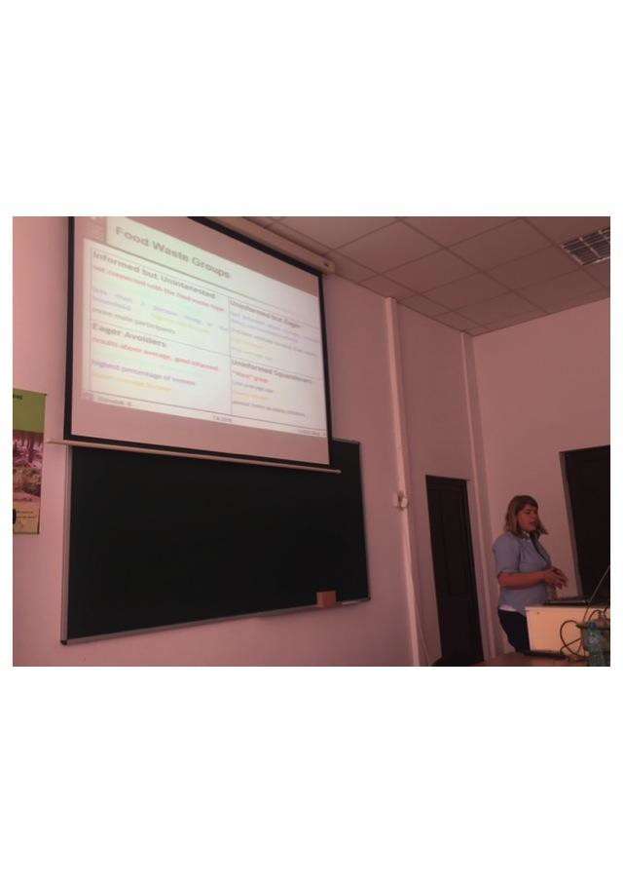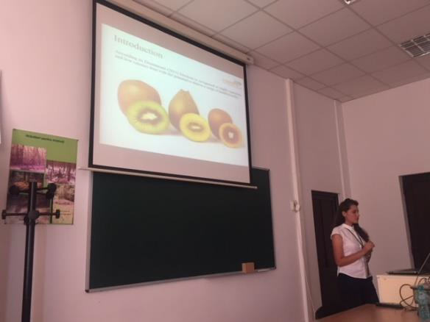

2018, June 8 The 9th CASEE Conference, Bucharest, Romania 3
Professor Ewa Rembialkowska, Professor Teodor Trasca

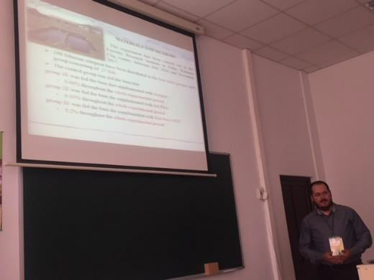3a.03 The effects of some fodder additives (Actigen, SelPlex, Yea- Sacc-1026) administered in the diet of Siberian sturgeon on meat quality, Sverinciuc Calin, Bentea M., Sara A., Coroian C., Clapa L., USAMV Cluj-Napoca, Romania
- research conducted on 108 juvenile Siberian sturgeon for 68 weeks
- control slaughters at the end of the experiment
  - the administration of bioadditives in the mixed fodder has caused:
    - decrease in the water content of the meat
    - increased content of crude protein

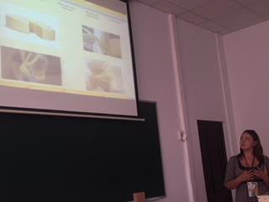3a.04 Production of Kashkaval cheese with enhanced flavor and microbioogical stability at ripening, Socaciu Maria, Simon, E.L., Fogarasi M.I., Jimborean M.A., Rotar A.M., Muresan C.C., Muresan V., Semeniuc C.A., USAMV Cluj-Napoca, Romania
-research conducted to develop a new type of cheese, Kashkaval cheese flavored with thyme
essential oil
-80 panelist evaluated the sensorial characteristics of the new developed cheese
  - thyme essential oil inhibited the growth of molds in Kashkaval cheese
  - the new product – enhanced flavor and improved microbiological quality

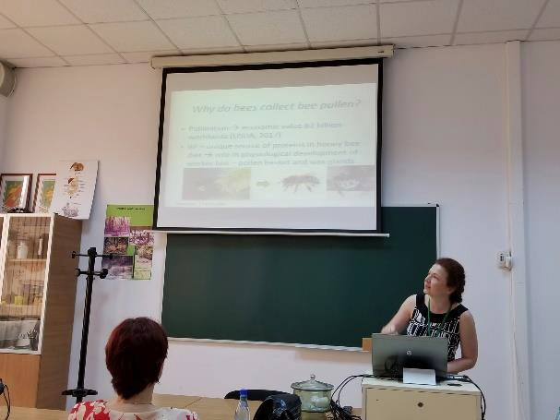3b.01 Bee pollen as antioxidant ingredient in ready-to-serve citrus juice, Stan Livia, USAMV Cluj-Napoca, Romania
-aim of the study: developing a citrus juice recipe (orange : lemon : grapefruit) enriched
with bee pollen
-the new products were evaluated for vit. C content, antioxidant activity, total phenols, sensory evaluation by 125 consumers
- bee pollen increases the nutritional value, easy to use
- the new product – highly accepted by consumers in ready-to-drink citrus
juices

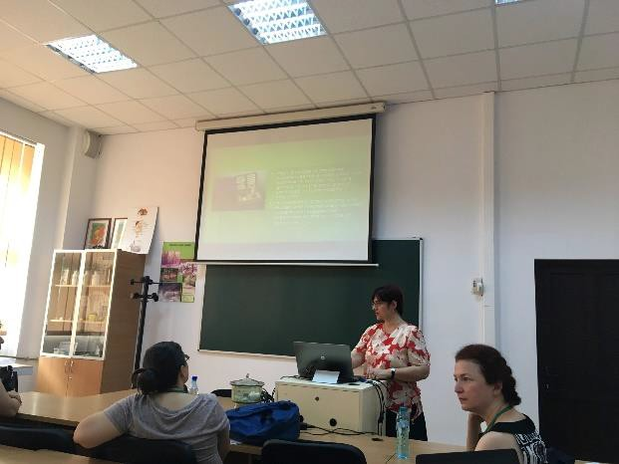3b.02 Effect of high dilutions of sodium chloride solutions on wheat germination, Rîndașu Ileana, Ciceoi R., Stănică F., USAMV Bucharest, Romania
-aim of the study: using wheat in an experiment with sodium chloride as a stressor and
various solutions of Natrium muriaticum (high dilutions of sodium chloride) as therapy
-the paper presented a an isopathic model, showing the effects of Natrium muriaticum on
the germination and growth of Glossa wheat variety
- 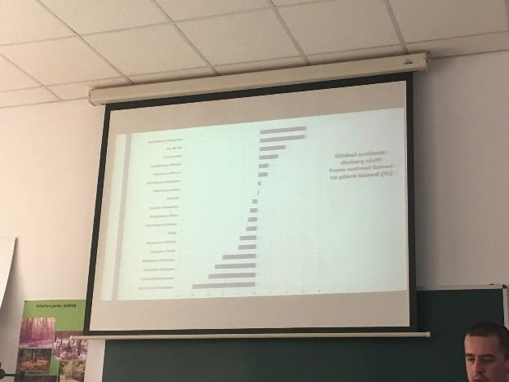the research open a new field in the domain of abiotic stress in plants treated with high diluted medicines

3b.03 The evolution of minimum arable land and food consumption from 1977 to 2013, Rotar I., Sîngeorzan Dragomir, USAMV Cluj-Napoca, Romania

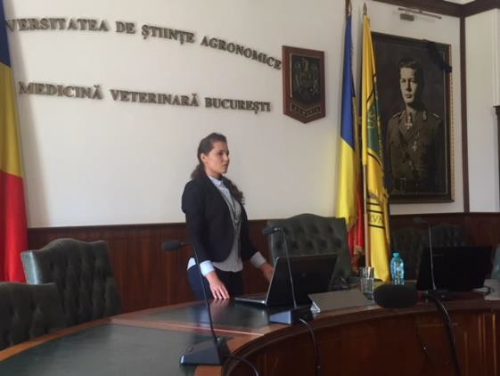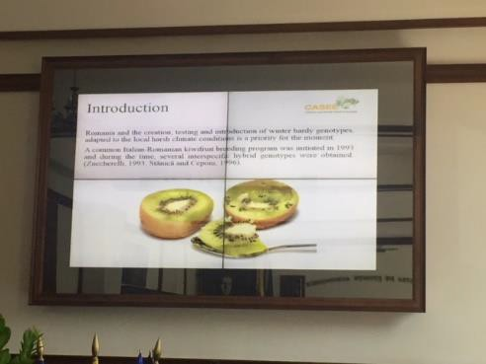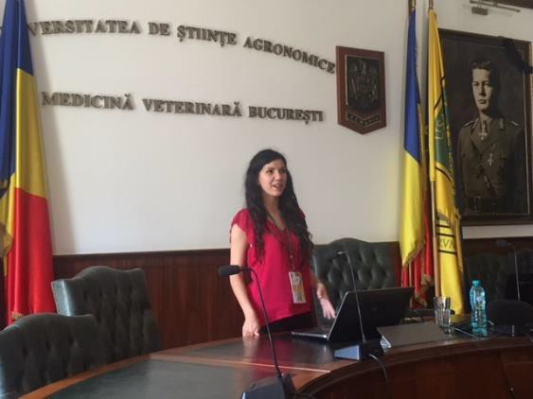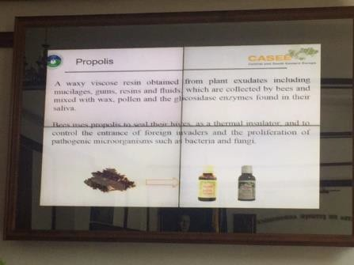3b.04 Kiwifruit preliminary characterization of some hybrid genotypes (Actinidia sp.), Iliescu Lavinia Mihaela, Stanică F., Butcaru A.C., Stan A., USAMV Bucharest, Romania
-kiwi fruits characterization of some new kiwi hybrid genotypes and the effects of
cold storage on postharvest fruit quality

3b.06 Antibacterial activity of some bee products and the possibility of their use in functional food production, Urcan Adriana, Criste A.D., Dezmirean D.D., Bobiș O., Mărghitaș L.A., USAMV Cluj-Napoca, Romania
-aim of the study: developing a functional food product with antimicrobial properties
which incorporate honey, propolis, royal jelly
- based on performed analysis, extraction of bioactives principles and characterization, testing antibacterial effect, honey and other bee products (royal jelly, propolis) may be used as functional foods because of their natural high antimicrobial and antioxidant potential

P3.01 – P3.10 – Poster evaluation based on 4 criteria:

•relevance to the topic: Sustainable food systems and quality
•clear scientific content and message
•clear aim and conclusions
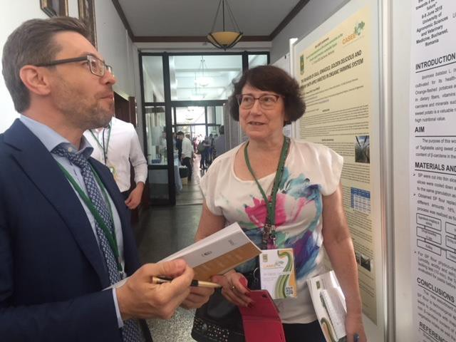•technical level of the poster (real poster, easy do understand, not just copy of the paper)

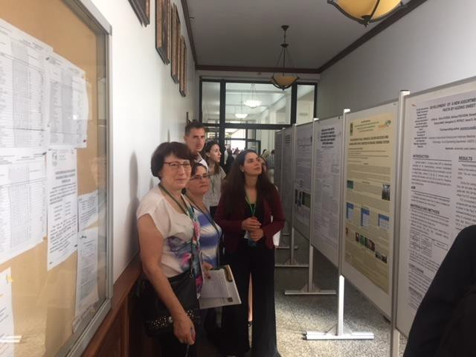

THANKYOU!

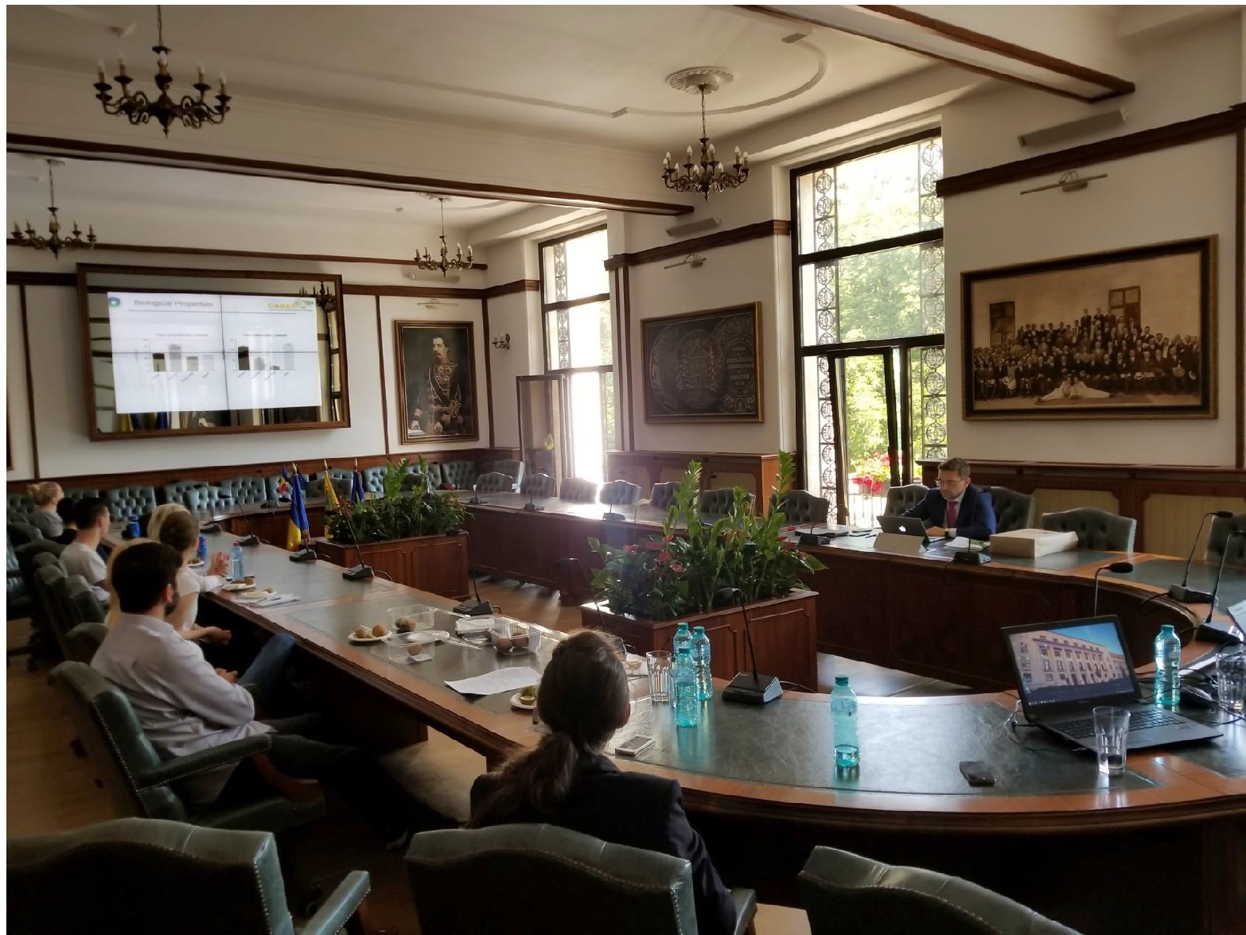
2018, June 8 The gth CASEE Conference , Bucharest, Romania
8
Professor Ewa Rembialkowska, ProfessorTeodor Trasca

